Relationship Manager Portal
Product Requirements Document
Small Business Banking | Financial Services
Status: Draft | March 2026

Table of Contents
1. Executive Summary
2. Background & Strategic Context
3. Goals & Success Metrics
4. User Personas & Stakeholders
5. Scope
6. User Journeys & Use Cases
7. Functional Requirements
8. Non-Functional Requirements
9. Data & Integrations
10. UX & Design Principles
11. Technical Architecture Considerations
12. Appendix

1. Executive Summary
Small Business Banking is a strategic growth engine for Truist — delivering low-cost, sticky deposits, diversified revenue, and serving as the primary feeder segment into Premier, Wealth, and Commercial as clients mature. Yet despite maintaining scale, recent performance reflects a familiar set of challenges: slowing deposit production, inconsistent banker productivity, and uneven client engagement across Small Business tiers.
The Relationship Manager Portal is a purpose-built digital workspace designed to address these gaps directly — making Small Business bankers more effective, more consistent, and more impactful at every stage of the client lifecycle. By embedding AI-driven insights, a GenAI Banker Co-Pilot, and guided workflows into a single, intuitive interface, the portal removes friction from the day-to-day and puts relationship managers back in control of their most important work: building and growing client relationships.

Why Now
Truist has spent several years making foundational investments in coverage model redesign, virtual sales, servicing optimization, and leadership realignment. These moves have stabilized the platform. The next phase of growth will not come from incremental headcount — it will come from productivity, precision, and scale. The portal is the mechanism to unlock that, by concentrating data and AI investment directly within frontline banker workflows.

What It Delivers
The portal is designed to drive four measurable outcomes:
- Banker effectiveness & consistency — Standardized workflows, AI-assisted client briefings, a GenAI Co-Pilot for call preparation and outreach, and guided next-best-action recommendations ensure every RM operates at the level of your best performers, regardless of tenure or experience.
- Funnel throughput & conversion — Clearer pipeline visibility, AI-prioritized client outreach, and reduced administrative burden allow RMs to spend more time in front of clients and move opportunities forward across deposits, lending, cash management, cards, and referrals.
- Measurable revenue lift — By surfacing prioritized "who, why, and what" decisioning at the point of action, the portal directly supports accelerated deposit, lending, and fee growth — with transparent, defensible KPIs tied to funnel performance and PPNR uplift.
- A reusable blueprint for scale — The portal is architected as a reusable foundation, with an initial focus on Small Business Banking (Tier I, Tier II, and Business Connect) and a clear path to extend into Premier, Wealth, and Commercial segments as the model matures.

Who It's For
The primary users are Small Business Relationship Managers — the frontline bankers responsible for client acquisition, deepening, and retention across Tier I, Tier II, and Business Connect (a distinct third tier) (a distinct third tier). The portal is designed around their daily workflow, minimizing context-switching and maximizing time spent on revenue-generating activity.

Measure of Success
Success will be evaluated against improvements in banker productivity and consistency, opportunity creation and win rates, client engagement frequency, and ultimately, attributable PPNR uplift — with transparent KPIs tied to funnel performance at each stage. The portal will also serve as the replicable blueprint for future segment rollouts beyond Small Business Banking.

2. Background & Strategic Context

The Role of Small Business Banking at Truist
Small Business Banking is a strategic growth engine for Truist. It generates low-cost, sticky deposits, contributes diversified revenue across lending, cards, and cash management, and serves as the primary feeder segment into Premier, Wealth, and Commercial as clients mature. The segment's health is not just a line-of-business concern — it is directly tied to Truist's long-term franchise value.

Current State Challenges
Despite maintaining scale, recent performance across the Small Business segment reflects three persistent challenges that this portal is designed to directly address:
- Slowing deposit production — Deposit growth has decelerated, with insufficient precision in how bankers identify, prioritize, and engage the right clients at the right time.
- Inconsistent banker productivity — Performance varies significantly across the RM population. The gap between top performers and the median represents a material, recoverable opportunity — one that better tooling and guided workflows can close.
- Uneven client engagement — Across Tier I, Tier II, and Business Connect, touchpoint frequency and engagement quality are inconsistent, leaving revenue on the table and increasing attrition risk.

Foundational Investments Already Made
Over the last several years, Truist has made meaningful foundational investments across the Small Business platform — including coverage model redesign, virtual sales capabilities, servicing optimization, and leadership realignment. These investments are ongoing and continue to evolve. The Relationship Manager Portal is designed to complement and accelerate this work — not to wait for it to be complete.

The Strategic Bet: improved productivity
The next phase of growth for Small Business Banking will come from making existing bankers meaningfully more productive — through better data, smarter prioritization, and AI-assisted workflows embedded directly in how they work. Project Thunderbolt was established to concentrate Truist's data and AI investment within the Small Business segment to prove this thesis, with the RM Portal as the primary delivery vehicle for frontline impact.

Why a Dedicated Portal
Salesforce remains Truist's CRM of record and will continue to serve as the system of action for pipeline management and opportunity tracking. However, Salesforce alone does not address the full scope of what RMs need in the flow of their daily work. A purpose-built portal fills this gap by:
- Surfacing AI-generated insights and Next Best Solution recommendations in a banker-friendly interface, without requiring RMs to construct their own queries or navigate complex CRM views.
- Providing a GenAI Banker Co-Pilot for client research, call preparation, talking points, and compliant email drafting — capabilities that Salesforce does not natively deliver.
- Aggregating signals from across Truist's data ecosystem (via Snowflake) into a unified Small Business client view that is optimized for lead lists, triggers, and pre-call preparation.
- Enabling referral pathways into Premier, Wealth, and Commercial — closing the loop on segment mobility and ensuring high-value clients are identified and handed off appropriately.

Path to Scale
The portal is explicitly designed as a reusable blueprint. While the initial build is scoped to Small Business Banking, the underlying data architecture, AI model framework, and workflow patterns are intended to extend into Premier, Wealth, and Commercial segments as the model matures and proves economic value. Demonstrating clear payback in Small Business is the first proof point — and the foundation for a broader enterprise rollout.

3. Goals & Success Metrics
Success for the RM Portal will be measured across three categories: banker productivity & activity, pipeline & conversion, and revenue & PPNR lift. Metrics are tracked at both the individual RM level and aggregated by tier. Targets below are directional estimates intended to anchor planning and pilot design — they should be validated against Truist's baseline data before being formally adopted.
Note: All targets are estimates pending baseline validation.

3.1 Banker Productivity & Activity
These metrics measure whether RMs are spending more time on high-value client activity and less time on administrative overhead.

Tier I
Portal adoption rate
- 3-month: 70% weekly active users within 90 days of launch *
- 3-year: 95% weekly active users *
Client touchpoints per RM per week
- 3-month: +15% increase from baseline *
- 3-year: +35% increase from baseline *
Time on admin vs. client activity
- 3-month: Reduce admin time by 10% *
- 3-year: Reduce admin time by 25% *
Co-Pilot usage rate
- 3-month: 50% of RMs using Co-Pilot for call prep *
- 3-year: Co-Pilot embedded in standard pre-call workflow *

Tier II
Portal adoption rate
- 3-month: 65% weekly active users within 90 days *
- 3-year: 90% weekly active users *
Client touchpoints per RM per week
- 3-month: +10% increase from baseline *
- 3-year: +30% increase from baseline *
Next Best Solution (NBS) action rate
- 3-month: 30% of surfaced NBS recommendations acted on *
- 3-year: 60% of surfaced NBS recommendations acted on *

Business Connect
Portal adoption rate
- 3-month: 60% weekly active users within 90 days *
- 3-year: 85% weekly active users *
Automated trigger-to-outreach rate
- 3-month: 40% of system-generated triggers result in RM outreach *
- 3-year: 75% of triggers result in outreach *

3.2 Pipeline & Conversion
These metrics assess whether the portal is improving how opportunities are created, managed, and closed across product lines.

Tier I
Opportunity creation rate
- 3-month: +20% increase in logged opportunities per RM *
- 3-year: +50% increase in logged opportunities per RM *
Pipeline-to-close conversion
- 3-month: +5 percentage points improvement from baseline *
- 3-year: +15 percentage points improvement from baseline *
Referral handoff rate to Premier/Wealth/Commercial
- 3-month: Baseline established; referral pathway live *
- 3-year: +40% increase in qualified referrals *

Tier II & Business Connect
NBS-to-opportunity conversion
- 3-month: 20% of acted-on NBS recommendations convert to tracked opportunities *
- 3-year: 45% of acted-on NBS recommendations convert to tracked opportunities *
Pipeline velocity
- 3-month: Baseline established in first 60 days *
- 3-year: Measurable reduction in average days-to-close *

3.3 Revenue & PPNR Lift
These are the ultimate lagging indicators of portal impact. 3-month targets focus on establishing measurement infrastructure and early signals; 3-year targets reflect mature, attributable impact.

All Tiers (Aggregated)
Deposit production
- 3-month: A/B test cohort established; early lift signal visible *
- 3-year: +10–15% deposit growth attributable to portal-assisted RMs vs. control *
Lending & fee revenue
- 3-month: Baseline measurement framework live *
- 3-year: Measurable incremental revenue from NBS-driven cross-sell *
PPNR uplift
- 3-month: Investment payback model validated with pilot data *
- 3-year: Demonstrated PPNR uplift aligned to Truist investment discipline *
Blueprint replication readiness
- 3-month: Small Business learnings documented and socialized *
- 3-year: At least one adjacent segment (Premier or Commercial) onboarded to portal *

3.4 Measurement Approach
To ensure defensible attribution, the following measurement principles will apply:
- A/B testing with control cohorts — Pilot rollout will include treatment and control groups at the RM level to isolate portal-driven impact from broader market or seasonal effects.
- Leading vs. lagging indicators — Activity and pipeline metrics serve as leading indicators (visible within 30–90 days); revenue and PPNR metrics are lagging and will be evaluated on a rolling 6–12 month basis.
- Funnel instrumentation — The portal will emit telemetry at each stage of the RM workflow to support funnel analysis and identify where drop-off occurs.
- Transparent KPI reporting — A performance dashboard will be available to RM managers and business line leadership, updated on a regular cadence.

4. User Personas & Stakeholders
The RM Portal serves three primary user types, each with distinct goals and needs. The Relationship Manager is the core user the portal is built around; the RM Team Lead and Business Line Executive are secondary users who interact with the portal primarily through performance and pipeline views.

Persona 1 — Relationship Manager

Tier I RM
Role summary
Manages a smaller, higher-value book of Small Business clients. Responsible for deep relationship cultivation, multi-product penetration, and identifying clients ready to graduate into Premier or Commercial. Expected to be highly proactive — personally driving outreach, opportunity creation, and client engagement rather than relying on system-generated prompts alone.
Key needs from the portal
- A unified view of each client's full relationship, product holdings, and interaction history — without toggling between systems.
- AI-generated pre-call briefings and talking points that surface relevant context before every client meeting.
- GenAI Co-Pilot for drafting compliant client communications and preparing for complex conversations.
- Clear visibility into which clients represent the highest expansion or referral potential.
- Frictionless interaction logging so activity is captured without adding to administrative overhead.

Tier II RM
Role summary
Manages a broader book of Small Business clients at moderate complexity. Balances proactive relationship management with a higher volume of accounts than Tier I. Relies more heavily on system-generated prioritization to identify where to focus energy, and on guided workflows to ensure consistent engagement quality across the portfolio.
Key needs from the portal
- AI-prioritized client lists that surface who to call, why, and what to discuss — reducing time spent deciding where to focus.
- Next Best Solution recommendations embedded directly in the client view, with clear 'why now' context to support banker confidence.
- Streamlined interaction logging and follow-up tracking to maintain coverage consistency across a larger book.
- Co-Pilot support for call preparation and outreach drafting, particularly for less familiar client situations.

Business Connect RM
Role summary
Manages the highest volume of accounts at the entry tier of Small Business Banking. Engagement is primarily trigger-driven and efficiency-focused. The portal must do significant work on their behalf — surfacing the right moments to act and making it as easy as possible to respond quickly and compliantly.
Key needs from the portal
- Automated trigger alerts that tell them exactly which clients to contact and why, without requiring manual portfolio analysis.
- One-click or templated outreach options that allow rapid, compliant client engagement at scale.
- Simple, mobile-friendly interaction logging to capture activity in the flow of work.
- Visibility into which clients show signals of upward segment mobility for referral to Tier II or Tier I coverage.

Persona 2 — RM Team Lead / Manager
Role summary
Oversees a team of RMs across one or more tiers. Responsible for performance management, coaching, and ensuring the team is meeting activity, pipeline, and revenue targets. Does not use the portal as a primary daily workspace but needs clear visibility into team-level performance to identify coaching opportunities and manage to plan.
Key needs from the portal
- Team-level dashboards showing RM activity rates, touchpoint frequency, pipeline health, and NBS action rates — at a glance.
- Ability to drill into individual RM performance to identify who is under-engaging their book or not acting on system recommendations.
- Visibility into Co-Pilot adoption and interaction logging compliance across the team.
- Early warning signals for at-risk client relationships or stalled pipeline opportunities that require manager intervention.

Persona 3 — Business Line Executive
Role summary
Senior leader accountable for the overall performance of Small Business Banking. Focused on strategic outcomes — deposit growth, revenue lift, and PPNR contribution — rather than day-to-day RM activity. Needs high-confidence data to make resourcing, investment, and segment expansion decisions, and to report progress against the Thunderbolt thesis to senior stakeholders.
Key needs from the portal
- Executive-level view of portfolio performance across tiers — deposit production, pipeline conversion, and revenue attribution.
- Transparent KPI tracking against 3-month and 3-year targets, with clear attribution methodology.
- Evidence of A/B test results and pilot cohort performance to support investment decisions and board-level reporting.
- Confidence that the portal is on track to serve as a replicable blueprint for Premier, Wealth, and Commercial expansion.

Stakeholder Map
Beyond the three primary user personas, the following stakeholders have a material interest in the portal's design, delivery, or outcomes:
Data & Analytics Team
Responsible for the Snowflake-based Small Business client data layer and NBS model outputs. Key input provider and dependency for portal data feeds.
IT / Engineering
Accountable for portal build, Salesforce integration, and ongoing infrastructure. Core delivery partner throughout the product lifecycle.
Model Risk Management (MRM)
Must validate AI and propensity models before production deployment. Governance and audit readiness are non-negotiable requirements.
Compliance & Legal
Reviews all client-facing content generated by the Co-Pilot and ensures fair lending, brand, and regulatory guardrails are in place.
Change Management & Enablement
Responsible for RM training, playbook development, and adoption telemetry. Critical to ensuring the portal translates to behavioral change in the field.

5. Scope
This section defines what is included in the initial MVP build, what is explicitly out of scope for v1, and the high-level phasing roadmap for capabilities that will follow.

5.1 In Scope — MVP (v1)
The MVP is scoped to the Small Business Banking segment (Tier I, Tier II, and Business Connect) and covers five core capability areas. The goal is to deliver a working, instrumented portal that proves the Thunderbolt thesis and generates the data needed to validate targets and inform future phases.
1. Unified Client View
A centralized, banker-facing profile for each Small Business client aggregating relationship history, product holdings, interaction logs, behavioral signals, and lifecycle indicators. Powered by the Snowflake-based Small Business client data layer. Designed as the single pane of glass RMs work from — eliminating the need to toggle between systems for client context.
2. Next Best Solution (NBS)
AI- and propensity model-driven recommendations surfaced directly within the client view, prioritizing outreach opportunities across deposits, lending, cash management, cards, and referrals. Each recommendation includes explicit "why now" context to support banker confidence and adoption. Embedded natively for Tier II and Business Connect; available as a supplemental signal layer for Tier I.
3. GenAI Banker Co-Pilot
A secure, chat-based GenAI assistant embedded within the portal for client and industry research, call preparation, probing question generation, talking points, and compliant email drafting. Operates fully within the Truist technology stack. Includes human-in-the-loop workflows, audit trails, hallucination mitigation, and brand and fair-lending guardrails.
4. Salesforce Integration
Bi-directional integration with Salesforce as the CRM of record. Portal activity, interaction logs, and opportunity updates sync to Salesforce so that the portal complements — rather than replaces — existing pipeline management workflows. RMs should not be required to log the same activity in two places.
5. Snowflake Data Layer
Design and implementation of the unified Small Business client data layer with Snowflake as the end-state platform. Integrates data across Truist systems, products, and client relationships. Provides the enriched attributes and signals (behavioral, lifecycle, risk, engagement) that power the unified client view and NBS recommendations. Supports APIs and integration patterns for Salesforce and downstream workflows.

5.2 Out of Scope — v1
The following are explicitly excluded from the v1 build. Inclusion in a future phase does not imply commitment — each item will be evaluated based on pilot learnings, resourcing, and strategic priority.
- External client-facing features — The portal is an internal banker tool. No client-facing functionality, portals, or communications are in scope for v1. All Co-Pilot-generated content is drafted by the RM for review before any client interaction.
- Premier, Wealth & Commercial segments — The initial build is scoped exclusively to Small Business Banking. Segment expansion is a future phase objective, contingent on proven value in Small Business.
- Native mobile app — v1 will be optimized for desktop use with confirmed mobile-responsive design. A dedicated native mobile application is not in scope for this release.
- Interaction capture automation — Automated call recording, transcription, or AI-assisted meeting summarization are not in scope for v1. Interaction logging will be manual, with AI-assisted summarization considered for a future phase.

5.3 Future Phases — High-Level Roadmap
The following phases are directional and subject to revision based on v1 pilot outcomes, business prioritization, and resourcing. They are included here to establish the intended trajectory of the platform and to ensure v1 architectural decisions account for future extensibility.
Phase 2 — Manager & Executive Dashboards
Build out team-level performance views for RM Team Leads and Business Line Executives, including activity tracking, pipeline health, NBS action rates, and KPI progress against 3-month and 3-year targets. Powered by telemetry established in v1.
Phase 3 — Interaction Capture & AI Summarization
Introduce automated interaction capture — including call logging, meeting summarization, and AI-assisted note generation — to further reduce RM administrative overhead and enrich the client interaction history over time.
Phase 4 — Segment Expansion
Extend the portal blueprint into adjacent segments, beginning with Premier and progressing to Wealth and Commercial. Each expansion will leverage the shared data architecture, NBS model framework, and Co-Pilot infrastructure established in Small Business.
Phase 5 — Mobile & Field Enablement
Develop a native mobile experience optimized for field-based RMs who need to log activity, access client briefings, and use the Co-Pilot on the go — without returning to a desktop environment.

6. User Journeys & Use Cases
This section describes the three core RM journeys the portal is designed to support: pre-call preparation, client outreach & follow-up, and opportunity management. Where the experience differs meaningfully across tiers, separate narratives are provided. Journeys are written from the RM's perspective and represent the intended end-state workflow once the portal is fully adopted.

Journey 1 — Pre-Call Preparation
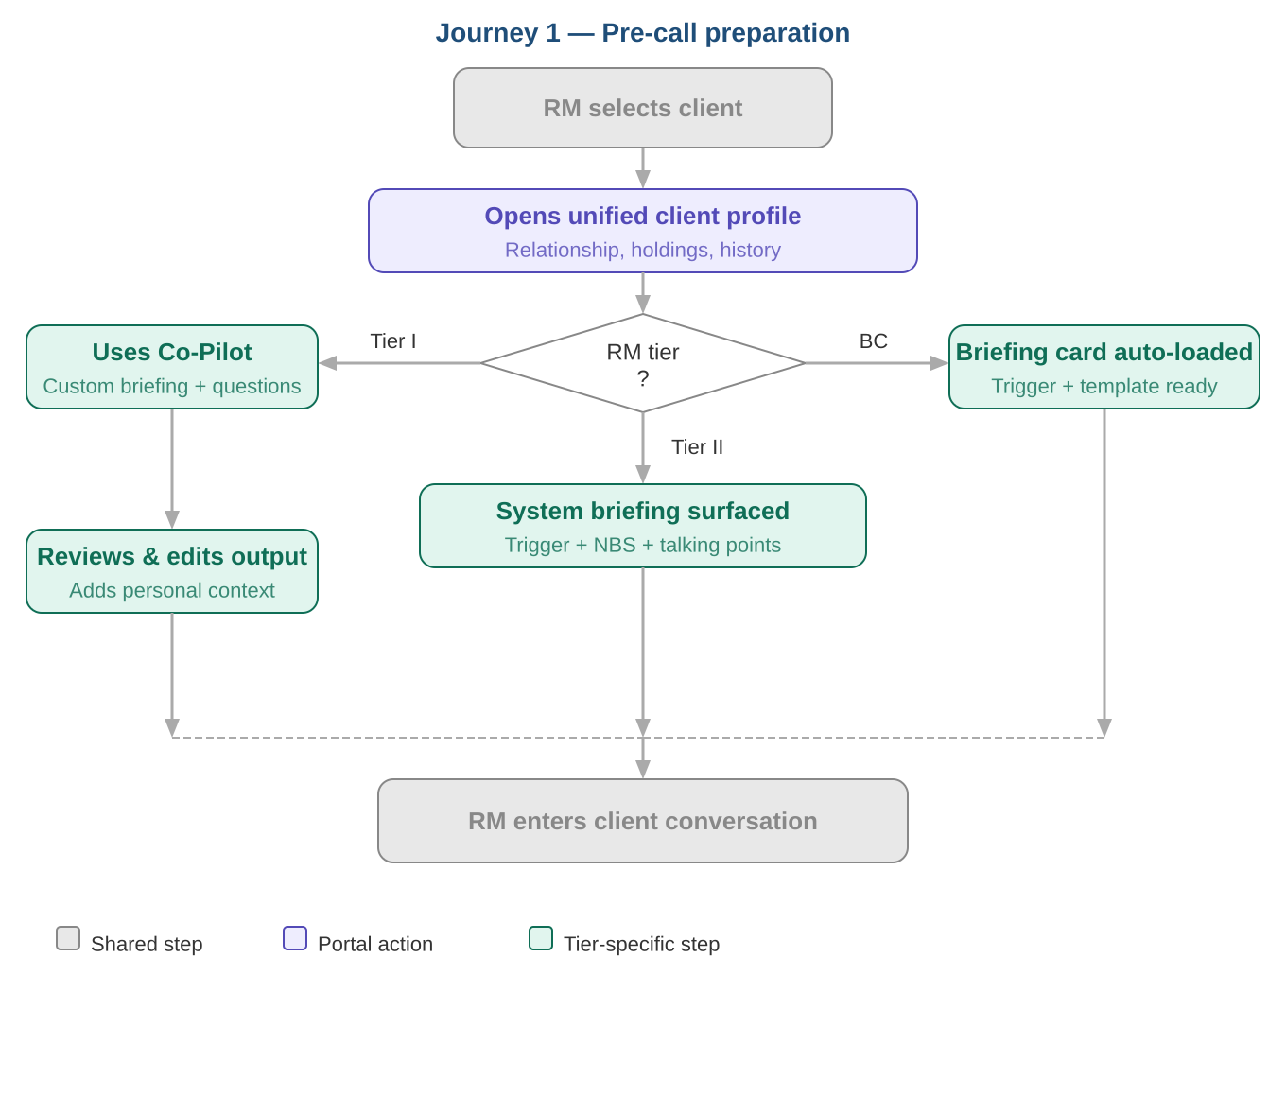
Goal: The RM arrives at every client conversation fully briefed — knowing the client's current relationship status, recent activity, open opportunities, and the most relevant talking points — without spending significant time pulling information from multiple systems.

Tier I
A Tier I RM has a relationship review scheduled with a long-standing Small Business client. Before the call, they open the portal and navigate to the client's unified profile. In a single view they can see the client's full product holdings, recent transaction signals, the last three interactions logged, and any open NBS recommendations. They activate the GenAI Co-Pilot and ask it to generate a pre-call briefing — the Co-Pilot synthesizes the client's recent activity, surfaces a relevant industry insight, and drafts three probing questions tailored to the client's business stage and current portfolio gaps. The RM reviews the output, edits one question to reflect a recent conversation they recall, and uses the briefing as their call guide. The entire preparation takes under five minutes.

Tier II
A Tier II RM is working through their prioritized client list for the day. The portal surfaces a client flagged with a trigger — a deposit balance decline over the past 30 days paired with an open NBS recommendation for a cash management conversation. The RM clicks into the client profile and immediately sees a system-generated briefing summarizing the trigger context, the recommended solution, and suggested talking points. They use the Co-Pilot to quickly draft a call opener and a follow-up email template in case the client is unavailable. Because the briefing is pre-generated and surfaced proactively, the RM spends less than two minutes preparing before dialing.

Business Connect
A Business Connect RM manages a high volume of accounts and cannot invest significant preparation time per client. The portal does the heavy lifting — each client flagged for outreach arrives with a pre-populated briefing card summarizing the trigger, the recommended action, and a templated outreach message ready to send or lightly personalize. The RM's primary decision is whether to act on the recommendation as presented or adjust the approach. Preparation is measured in seconds, not minutes, enabling the RM to cover more ground without sacrificing relevance.

Journey 2 — Client Outreach & Follow-Up
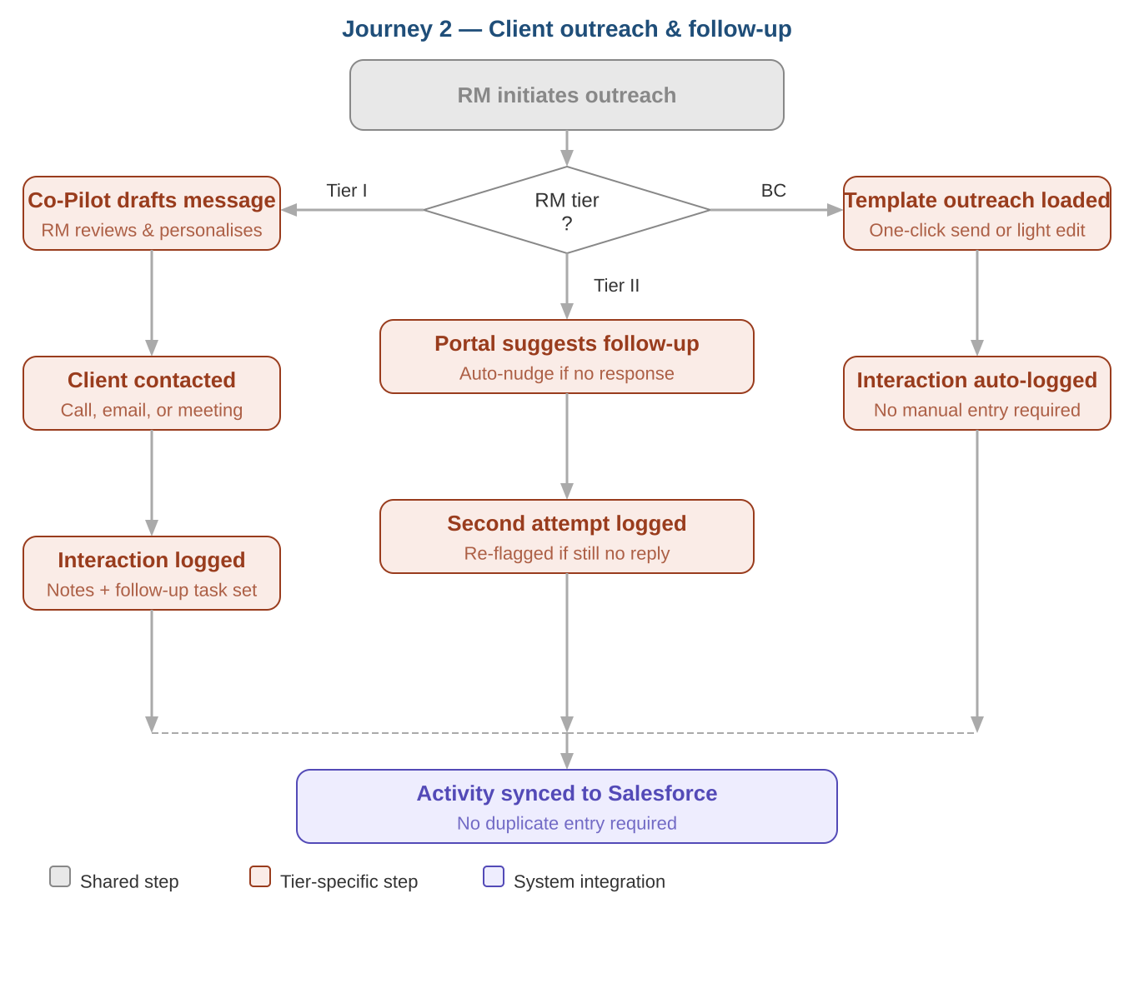
Goal: The RM initiates timely, relevant, and compliant client outreach — and closes the loop with logged follow-up — without leaving the portal or duplicating effort in Salesforce.

Tier I
Following their pre-call preparation, a Tier I RM completes a client conversation and immediately logs the interaction within the portal. They capture key discussion points, note the client's expressed interest in a lending product, and flag a follow-up task with a due date. The Co-Pilot drafts a follow-up email summarizing the call and outlining next steps — the RM reviews it, makes minor edits, and sends it directly. The interaction log and the follow-up task automatically sync to Salesforce, so the pipeline record reflects the latest activity without any duplicate entry. The RM's manager can see the touchpoint in the team dashboard by end of day.

Tier II
A Tier II RM receives an alert that a client they contacted last week has not responded. The portal surfaces the original outreach context alongside a suggested follow-up message generated by the Co-Pilot, referencing the prior touchpoint and the original NBS recommendation. The RM sends the follow-up with one click, and the portal logs the second attempt automatically. If the client still does not respond after the next interval, the portal flags the relationship for review — surfacing it in the RM's daily priority list with a recommendation to either escalate or adjust the outreach approach.

Business Connect
For Business Connect RMs, outreach is largely templated and trigger-driven. When a trigger fires, the portal presents a pre-drafted outreach message aligned to the recommendation type. The RM selects, optionally personalizes, and sends — with the interaction logged automatically. The focus is on making compliant, relevant outreach as frictionless as possible so that high trigger volumes translate into high contact rates without overwhelming the RM.

Journey 3 — Opportunity Management
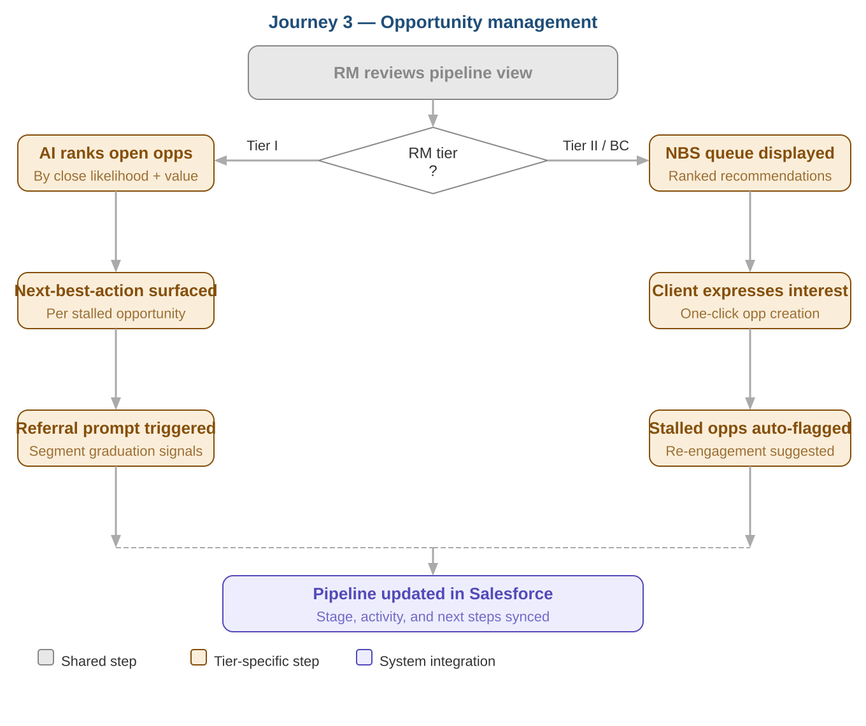
Goal: The RM maintains a clear, current view of their open opportunities — knowing what stage each is at, what action is needed to move it forward, and when to escalate or refer — without relying on manual pipeline hygiene in Salesforce.

Tier I
A Tier I RM starts their week by reviewing their opportunity pipeline within the portal. The view surfaces open opportunities ranked by likelihood to close and revenue potential, with an AI-generated next-best-action for each. For a lending opportunity stalled at proposal stage, the portal flags that no activity has been logged in 12 days and suggests a follow-up approach. For a client showing signals of segment graduation — increasing deposits, expanding headcount, new product inquiries — the portal prompts the RM to initiate a referral to Premier. The RM acts on both recommendations directly from the pipeline view, logging the actions and updating opportunity stages without switching to Salesforce.

Tier II & Business Connect
For Tier II and Business Connect RMs, opportunity management is more tightly coupled to NBS recommendations than to a self-managed pipeline. When an RM acts on an NBS recommendation and a client expresses interest, the portal prompts them to convert the interaction into a tracked opportunity with one click — pre-populating the product type, estimated value, and expected close timeframe based on the recommendation context. The RM's pipeline view then reflects these in-flight opportunities alongside their NBS queue, giving them a unified picture of active work without requiring manual pipeline construction. Stalled opportunities are surfaced automatically with suggested re-engagement actions, keeping the pipeline current with minimal RM overhead.

7. Functional Requirements
Functional requirements are organized by priority tier and grouped by capability module. Requirements marked [P2] are out of scope for MVP and are targeted for Phase 2 delivery.
- Must Have — Core requirements without which the portal cannot achieve its primary objectives. Required for MVP launch.
- Should Have — High-value requirements that significantly improve the experience but do not block launch if deferred.
- Nice to Have — Enhancements that add polish or efficiency but carry lower priority relative to must-have and should-have items.

7.1 Unified Client View
The unified client view is the core workspace of the portal — the single pane of glass from which RMs manage all client context and activity.
Must Have
- FR-01 The portal must display a unified client profile aggregating product holdings, relationship history, interaction logs, and behavioral signals from the Snowflake data layer.
- FR-02 The portal must surface the client's current tier classification (Tier I, Tier II, Business Connect) and flag any signals of segment mobility.
- FR-03 The portal must display the date and summary of the last logged interaction for each client.
- FR-04 The portal must allow RMs to search for clients by name, business name, account number, or assigned RM.
- FR-05 The portal must display open NBS recommendations on the client profile, with associated 'why now' context for each.
- FR-06 The portal must provide a prioritized daily client list for each RM, ranked by AI-generated engagement urgency.
Should Have
- FR-07 The portal should allow RMs to filter and sort their client list by tier, last contact date, NBS recommendation type, and engagement score.
- FR-08 The portal should display enriched client attributes including industry, business lifecycle stage, and risk indicators where available from the data layer.
- FR-09 The portal should surface alerts for clients with no logged interaction beyond a configurable threshold (e.g. 30 days for Tier I, 14 days for Tier II).
Nice to Have
- FR-10 The portal may display a relationship health score per client, aggregating engagement frequency, product breadth, and NBS action rate into a single indicator.
- FR-11 The portal should provide a manager view of client coverage across an RM's full book, showing engagement gaps at the portfolio level.

7.2 Next Best Solution (NBS)
NBS is the AI-driven recommendation engine that surfaces prioritized client opportunities across product lines, with explicit context to support banker confidence and adoption.
Must Have
- FR-12 The portal must surface NBS recommendations per client across deposits, lending, cash management, cards, and referrals, ranked by propensity model output.
- FR-13 Each NBS recommendation must include a 'why now' rationale derived from behavioral signals, lifecycle triggers, or portfolio events.
- FR-14 NBS recommendations must be embedded natively within the client profile view for Tier II and Business Connect RMs.
- FR-15 The portal must allow RMs to mark an NBS recommendation as acted on, dismissed, or deferred — with the status reflected in the client record.
- FR-16 NBS models must be validated and approved through Truist's Model Risk Management (MRM) process before production deployment.
Should Have
- FR-17 The portal should allow RMs to provide feedback on NBS recommendation quality (e.g. not relevant, already in progress) to support model improvement.
- FR-18 NBS recommendations should refresh on a defined cadence (e.g. daily or weekly) as new signals are processed through the Snowflake data layer.
- FR-19 The portal should support referral pathway recommendations — flagging clients showing signals of graduation to Premier, Wealth, or Commercial.
Nice to Have
- FR-20 The portal may display NBS recommendation performance metrics to RMs (e.g. acceptance rate for similar recommendations across the segment).
- FR-21 The portal should support team-level NBS adoption dashboards for RM Team Leads, showing action rates by RM and recommendation type.

7.3 GenAI Banker Co-Pilot
The Co-Pilot is a secure, chat-based GenAI assistant embedded within the portal. It assists RMs with research, call preparation, and compliant client communications — operating fully within Truist's technology stack.
Must Have
- FR-22 The Co-Pilot must support natural language queries against the client's full relationship history, product holdings, and interaction log.
- FR-23 The Co-Pilot must generate pre-call briefings, suggested probing questions, and talking points tailored to the specific client context.
- FR-24 The Co-Pilot must support drafting of client-facing email communications, with outputs subject to RM review before sending.
- FR-25 The Co-Pilot must operate within Truist's approved technology stack with no vendor-owned client data interactions.
- FR-26 The Co-Pilot must implement brand guardrails and fair-lending compliance controls on all generated outputs.
- FR-27 The Co-Pilot must maintain a full audit trail of queries and generated outputs, accessible for compliance review.
- FR-28 The Co-Pilot must include hallucination mitigation controls and surface confidence indicators or caveats where appropriate.
Should Have
- FR-29 The Co-Pilot should support industry research queries, surfacing relevant sector trends and business context for client conversations.
- FR-30 The Co-Pilot should allow RMs to save and reuse generated outputs (e.g. email templates, briefing formats) for similar client situations.
- FR-31 The Co-Pilot should support human-in-the-loop review workflows, flagging outputs that require compliance sign-off before use.
Nice to Have
- FR-32 The Co-Pilot may support voice-to-text input for RMs logging notes or querying client context on the go.
- FR-33 [P2] The Co-Pilot may be extended to support post-meeting summarization once automated interaction capture is introduced in Phase 3.

7.4 Interaction Logging
Interaction logging captures RM activity against client records, feeding the interaction history that powers client profiles, NBS models, and the Co-Pilot.
Must Have
- FR-34 The portal must allow RMs to manually log interactions against a client record, capturing interaction type (call, email, meeting), date, and free-text notes.
- FR-35 Logged interactions must sync to Salesforce automatically, without requiring duplicate entry by the RM.
- FR-36 The portal must allow RMs to set follow-up tasks with due dates directly from the interaction log.
- FR-37 Interaction logs must be visible to the RM's team lead within the portal.
Should Have
- FR-38 The portal should allow the Co-Pilot to assist with note summarization after an interaction is logged, generating a structured summary from free-text input.
- FR-39 The portal should surface overdue follow-up tasks prominently in the RM's daily priority view.
Nice to Have
- FR-40 [P2] The portal may support automated interaction capture via call recording, transcription, and AI-assisted summarization in a future phase.

7.5 Salesforce Integration
Salesforce remains Truist's CRM of record. The portal must integrate tightly with Salesforce to ensure activity captured in the portal is reflected in the pipeline without creating duplicate workflows for RMs.
Must Have
- FR-41 The portal must support bi-directional sync with Salesforce for interaction logs, opportunity stages, and follow-up tasks.
- FR-42 Opportunity records created or updated in the portal must be reflected in Salesforce without manual re-entry by the RM.
- FR-43 The portal must read existing client and opportunity data from Salesforce to populate the unified client view on initial load.
- FR-44 Sync failures must surface a clear error state to the RM and log the failure for IT resolution — data must never silently fail to sync.
Should Have
- FR-45 The portal should provide a clear visual indicator to the RM confirming when a record has successfully synced to Salesforce.
- FR-46 The portal should support conflict resolution logic when the same record is updated in both the portal and Salesforce concurrently.

7.6 Snowflake Data Layer
The Snowflake-based Small Business client data layer is the foundational data platform that powers the unified client view and NBS recommendations. It must be designed for extensibility as the portal expands to additional segments.
Must Have
- FR-47 The data layer must integrate data across Truist systems, products, and client relationships into a unified Small Business client view.
- FR-48 The data layer must support enriched client attributes including behavioral, lifecycle, risk, and engagement indicators.
- FR-49 The data layer must provide banker-facing logical views optimized for lead lists, NBS triggers, and pre-call preparation.
- FR-50 The data layer must expose APIs and integration patterns compatible with Salesforce and portal downstream workflows.
- FR-51 The data layer must support model monitoring, validation, and fairness testing as required by Truist's MRM governance framework.
Should Have
- FR-52 The data layer should refresh client signals and NBS outputs on a defined schedule (e.g. nightly) to ensure portal data reflects current client state.
- FR-53 The data layer should be architected to support extension into Premier, Wealth, and Commercial client data in future phases without requiring a rebuild.

8. Non-Functional Requirements
Non-functional requirements define the quality attributes the portal must exhibit to be fit for production use in a regulated banking environment. Requirements are numbered with an NFR prefix and organized by category. All requirements apply to the MVP unless explicitly marked [P2].

8.1 Performance & Availability
Performance requirements ensure the portal is responsive enough to fit naturally into an RM's daily workflow without becoming a source of friction. Availability requirements ensure RMs can rely on the portal as a primary workspace during business hours.
- NFR-01 The portal must load the unified client profile view within 3 seconds under normal operating conditions for 95% of requests.
- NFR-02 NBS recommendations must load within 2 seconds of the client profile being opened for 95% of requests.
- NFR-03 Co-Pilot responses to RM queries must begin streaming within 5 seconds of submission for 90% of requests. Full response generation time will vary based on query complexity.
- NFR-04 The portal must achieve a minimum uptime of 99.5% during core business hours (7:00 AM – 7:00 PM local time, Monday through Friday), excluding planned maintenance windows.
- NFR-05 Salesforce sync operations must complete within 10 seconds of an interaction or opportunity update being submitted by the RM.
- NFR-06 The portal must degrade gracefully in the event of a downstream dependency failure (e.g. Snowflake or Salesforce unavailability) — surfacing a clear error state rather than a blank or broken interface, and retaining any locally cached client data where possible.
- NFR-07 Planned maintenance windows must be scheduled outside of core business hours and communicated to RM users with a minimum of 48 hours notice.

8.2 Scalability
Scalability requirements ensure the portal can support growth in user volume, client data volume, and geographic or segment expansion without requiring a fundamental re-architecture. Given the portal's role as a reusable blueprint, these requirements are particularly important.
- NFR-08 The portal must support concurrent usage by all active Small Business RMs across Tier I, Tier II, and Business Connect (a distinct third tier) without degradation in response time below the thresholds defined in NFR-01 through NFR-03.
- NFR-09 The portal architecture must support a 3x increase in concurrent user load — anticipated as the platform expands to additional segments — without requiring core infrastructure changes.
- NFR-10 The Snowflake data layer must be designed to accommodate a growing volume of enriched client attributes and behavioral signals without impacting query performance for banker-facing views.
- NFR-11 The NBS model serving infrastructure must be capable of generating and refreshing recommendations for the full Small Business client population within the defined overnight batch window.
- NFR-12 The portal's integration patterns — including Salesforce sync and Snowflake data feeds — must be designed as reusable, configurable components that can be extended to support Premier, Wealth, and Commercial segments with minimal re-engineering.
- NFR-13 The Co-Pilot infrastructure must support concurrent query load from all active RMs during peak usage periods (e.g. morning pre-call preparation windows) without exceeding the response time thresholds defined in NFR-03.
- NFR-14 [P2] As the portal expands to additional segments, the user management and role-based access control framework must support the addition of new user populations without requiring architectural changes to the access model.

9. Data & Integrations

9.1 Integration Architecture
The diagram below illustrates the integration architecture for the RM Portal MVP. All components operate within the Truist technology boundary. The portal sits at the center — consuming enriched client data from the Snowflake data layer, integrating bi-directionally with Salesforce as the CRM of record, and serving as the primary workspace for Relationship Managers across all three tiers.
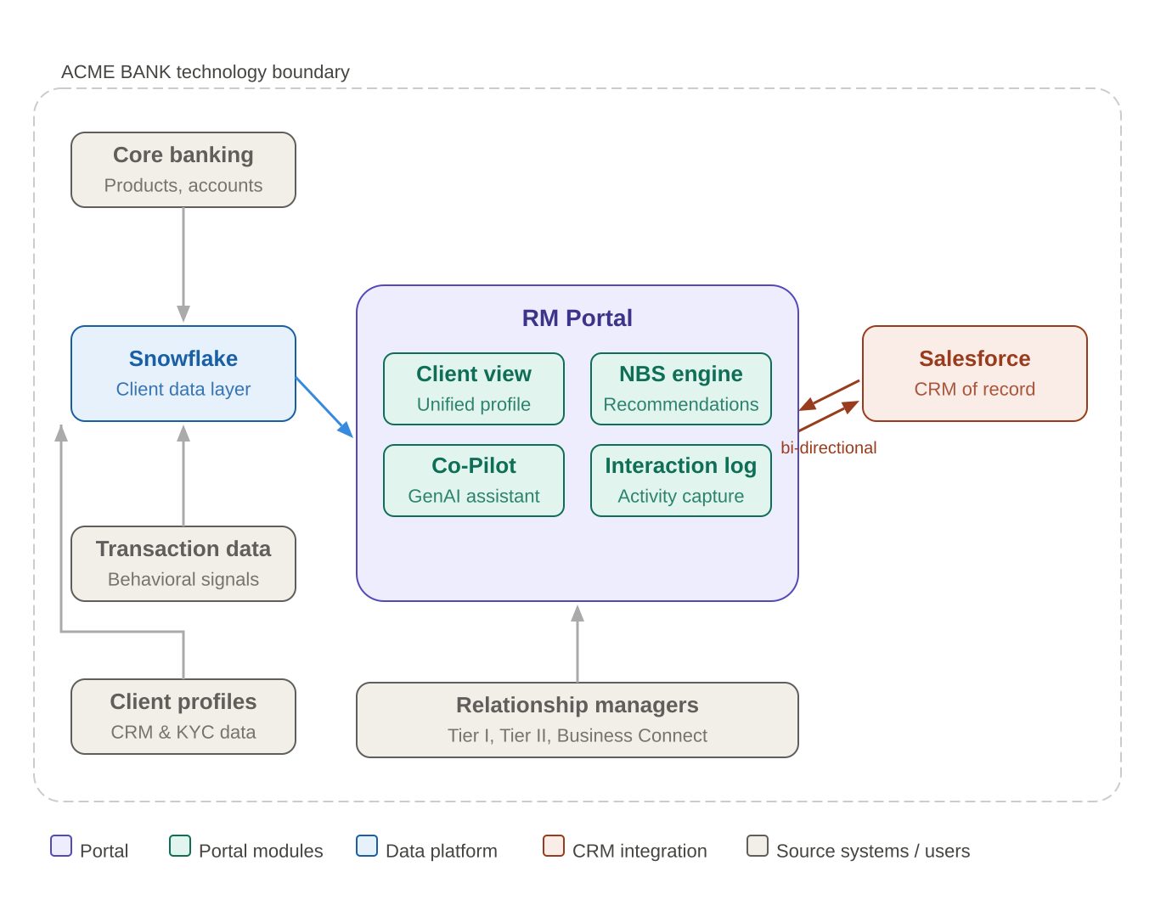

9.2 Integration Summary
The portal integrates with four categories of systems:
- Snowflake (data layer) — The primary source of enriched Small Business client data. Snowflake aggregates signals from core banking, transaction data, and client profile systems into banker-facing views that power the unified client profile and NBS recommendations. Data refreshes on a nightly batch cadence. The portal reads from Snowflake; it does not write back to it.
- Salesforce (CRM of record) — Bi-directional integration. The portal reads existing client and opportunity data from Salesforce to populate the unified client view on load. Interaction logs, opportunity updates, and follow-up tasks created in the portal are pushed back to Salesforce automatically, ensuring the CRM remains current without requiring duplicate RM entry.
- Core banking & transaction systems — Upstream sources that feed the Snowflake data layer. These systems are not directly integrated with the portal — all data from these sources is accessed via Snowflake. This architecture insulates the portal from direct dependencies on core banking systems and simplifies future source system changes.
- Client profile systems (CRM & KYC) — Client demographic, KYC, and relationship data that enriches the Snowflake client view. As with other source systems, this data flows through Snowflake rather than being consumed directly by the portal.

9.3 Key Integration Principles
- Portal complements Salesforce — it does not replace it — Salesforce remains the system of record for pipeline and opportunity management. The portal is the workspace; Salesforce is the record. RMs should never be required to enter the same data in both.
- All data flows within the Truist technology boundary — No client data is sent to external vendors or third-party platforms. The Co-Pilot operates on Truist infrastructure. This is a hard requirement with no exceptions.
- Snowflake as the data abstraction layer — By routing all source system data through Snowflake, the portal is decoupled from individual upstream systems. Changes to core banking or CRM platforms do not require portal re-engineering — only Snowflake feed updates.
- Designed for extensibility — Integration patterns are built as reusable, configurable components. Adding a new segment (e.g. Premier) to the portal should require Snowflake view configuration and access control updates — not a new integration build.

10. UX & Design Principles
This section defines the design principles that should guide all UX decisions for the RM Portal. These principles are not visual specifications — they are the decision-making framework that design and engineering teams should apply when resolving trade-offs, prioritizing features, and evaluating implementation options. Gong.io has been identified as the primary UX reference for the portal; relevant patterns are noted where applicable.

10.1 Core Design Principles
Single pane of glass
The portal must eliminate context-switching as a source of friction. Every piece of information an RM needs to prepare for, execute, and follow up on a client interaction should be accessible without leaving the portal. If an RM needs to open a second system to complete a workflow, the portal has failed that workflow. This is the foundational principle from which all others follow.
Progressive disclosure
The portal should always lead with the most actionable summary and allow RMs to drill into detail on demand. A client profile should open to a clean summary view — key signals, open recommendations, last interaction — not a wall of raw data. Depth is available, but never imposed. This principle applies at every level: the daily priority list surfaces top actions first; the Co-Pilot leads with a concise briefing before offering detailed analysis; NBS recommendations show the recommendation before the rationale.
AI as assistant, not authority
The portal's AI capabilities — NBS recommendations, Co-Pilot outputs, priority rankings — are designed to inform and accelerate RM judgment, not replace it. Every AI-generated output must be clearly marked as such, and RMs must always be able to override, dismiss, or act contrary to a recommendation without friction. The portal should make it easy to act on AI suggestions; it must never make it hard not to.
Minimal administrative burden
Every workflow in the portal should be evaluated against the question: does this make the RM's job easier, or does it create new overhead? Interaction logging must be fast. Opportunity updates must happen as a byproduct of natural workflow actions. The Co-Pilot should reduce the time RMs spend writing, not add a new editing step. If a feature adds administrative burden without a clear productivity payoff, it should be redesigned or deferred.
Consistency with existing tools
The portal is designed to complement Salesforce, not replace it. UX patterns, terminology, and data representations should be consistent with what RMs already see in Salesforce wherever possible. Introducing new conventions should be deliberate and justified — not a byproduct of building something new.

10.2 Information Hierarchy
The portal surfaces a large volume of client data, AI-generated outputs, and workflow prompts. Without a clear information hierarchy, the interface will feel overwhelming rather than empowering. The following principles govern how information should be prioritized and presented.
Action over information
The most prominent visual elements on any screen should be the actions the RM needs to take — not the data that supports those actions. An NBS recommendation should be more prominent than the signal that generated it. A follow-up task due today should be more prominent than the full interaction history.
Tier-appropriate defaults
The default information density of the portal should be calibrated to the RM's tier. Tier I RMs benefit from richer client context and deeper AI briefings presented by default. Business Connect RMs benefit from a stripped-back view focused on trigger alerts and templated actions. The portal should not present a one-size-fits-all interface — tier should drive the default layout and information depth, with the ability to expand or collapse as needed.
Signal over noise
The portal should be opinionated about what matters. A client with no activity in 30 days and an open NBS recommendation should surface prominently. A client with strong recent engagement and no open actions should recede. Alerts and notifications must be ruthlessly prioritized — the portal should never surface a low-priority notification in the same visual space as a high-urgency action item.
Recency and relevance over completeness
When displaying interaction history, NBS recommendations, or AI-generated content, the portal should default to the most recent and most relevant items — not a complete chronological list. Complete history is available on demand; the default view should reflect what matters now.

10.3 Mobile Considerations
A native mobile application is out of scope for v1. However, field-based RMs — particularly at Tier I — regularly conduct client meetings away from a desktop environment. The portal's v1 build must account for mobile use within the constraints of a responsive web experience.
Mobile-responsive by default
The portal must be built with a responsive layout that renders correctly on tablet and mobile browsers. While the primary design target is desktop, RMs should be able to access client profiles, review NBS recommendations, and log interactions from a mobile browser without a broken or unusable experience.
Prioritize logging and lookup on mobile
The two most common mobile use cases are interaction logging (capturing notes immediately after a meeting) and client lookup (reviewing a briefing immediately before a conversation). These flows should be explicitly tested and optimized for mobile viewports — even if the full portal experience is desktop-first.
Co-Pilot on mobile
The Co-Pilot chat interface should be functional on mobile. RMs should be able to query a client briefing, generate a talking point, or draft a follow-up email from a mobile browser. Full feature parity with desktop is not required, but core query and generation workflows must be operable.
Native mobile as Phase 5
A dedicated native mobile application — with offline capability, push notifications, and a mobile-optimized interaction logging flow — is targeted for Phase 5. Design decisions made in v1 should not foreclose a clean native mobile implementation in the future. In particular, the Co-Pilot and interaction logging APIs should be designed with a mobile-first consumption pattern in mind, even if the v1 client is web-based.

10.4 Gong.io UX Reference
Gong.io has been identified as the primary interaction reference for the portal. The following Gong patterns are directly applicable to the RM Portal design and should be reviewed by the design team prior to wireframing. Full competitive analysis is documented in the Appendix.
- Account summary cards — Gong's approach to surfacing the most relevant account context at a glance, with progressive drill-down to detail. Directly applicable to the unified client profile view.
- AI-generated briefings — Gong's 'Ask Anything' and account summary patterns for AI-generated pre-call context. Applicable to the Co-Pilot briefing generation flow.
- Prioritized alert surfaces — Gong's approach to surfacing actionable alerts without creating notification overload. Directly applicable to NBS recommendation and trigger alert design.
- Inline activity logging — Gong's patterns for capturing interaction notes without leaving the account view. Applicable to the interaction logging flow.
- Pipeline health views — Gong Forecast's approach to surfacing at-risk accounts and stalled opportunities. Applicable to the opportunity management view.

11. Technical Architecture Considerations
This section documents the key architectural decisions and constraints that should guide the engineering approach for the RM Portal. It is not a technical specification — it is a set of directional considerations intended to ensure the portal is built on a foundation that supports both the MVP and the longer-term platform vision.

11.1 The Core Architectural Question
The central architectural question for the RM Portal is not what to build — it is where the interaction layer should live, both now and over time. Three platforms sit at the heart of this question, each with a distinct role:
- Snowflake — The data platform. Snowflake houses the enriched Small Business client data layer and powers NBS model outputs. It is a data store and compute engine — not an interaction surface. RMs do not interact with Snowflake directly; the portal and Salesforce consume from it. Snowflake's role is to be the single, authoritative source of enriched client intelligence.
- Salesforce — The CRM of record and a potential MVP interaction layer. Salesforce already holds client and opportunity data, and RMs have established workflows within it. For the MVP, Salesforce is the most pragmatic candidate for hosting certain interaction surfaces — particularly opportunity management and interaction logging — given existing adoption, data residency, and integration maturity. Embedding lightweight portal capabilities directly within Salesforce (e.g. via a Salesforce Lightning component) is a viable MVP delivery pattern that minimizes change management burden.
- Microsoft 365 Copilot — The desired long-term interaction layer. Truist's stated direction is toward Microsoft 365 Copilot as the enterprise AI interaction surface. This has direct implications for the Co-Pilot: the GenAI assistant built for the RM Portal should be architected as a capability that can be surfaced within Microsoft 365 Copilot in a future phase — not as a standalone portal-only tool that would need to be rebuilt when the platform transition occurs.

11.2 MVP Interaction Layer — Recommended Approach
Given the three-platform context above, the recommended MVP architectural approach is a Salesforce-anchored interaction layer with an abstracted Co-Pilot service:
- Salesforce as the MVP interaction anchor — For the unified client view, NBS recommendations, interaction logging, and opportunity management, the MVP should leverage Salesforce as the primary interaction surface — either through a purpose-built Salesforce app or embedded Lightning components. This approach minimizes re-platforming risk, respects existing RM workflows, and ensures data written by RMs lands directly in the CRM of record without a sync dependency.
- Co-Pilot as a standalone service, consumed by the portal — The GenAI Banker Co-Pilot should be built as an independent, API-accessible service — not tightly coupled to the portal front-end or to Salesforce. This architecture allows the Co-Pilot to be surfaced in the portal today, embedded in Salesforce tomorrow, and exposed through Microsoft 365 Copilot in a future phase — without requiring a rebuild of the underlying capability each time the interaction surface changes.
- Snowflake as data platform and trigger engine — While the portal consumes data from Snowflake without writing back to it, Snowflake plays a more active role than a passive data store. In addition to housing enriched client data and NBS model outputs, Snowflake runs a series of ML-driven trigger models that fire downstream workflows into Salesforce when defined conditions are met. These triggers are the mechanism by which NBS 'why now' context is generated and surfaced to RMs. See Section 11.2a for detail on the trigger architecture.

11.2a Snowflake ML Trigger Architecture
Snowflake serves a dual role in the portal architecture: it is both the housing platform for enriched client data and the engine that runs ML-driven trigger models. These triggers are distinct from the NBS propensity models — they are event-detection models that monitor client signals on a defined cadence and fire a downstream notification into Salesforce when a threshold condition is met.

How triggers work
- Signal monitoring — Snowflake continuously processes enriched client data against a library of ML trigger models. Each trigger model monitors a specific signal type — for example, a deposit balance decline exceeding a defined threshold, a change in transaction frequency, a lifecycle event such as a business anniversary, or a cross-sell propensity score crossing a confidence threshold.
- Trigger firing — When a trigger condition is met, Snowflake generates a trigger event record containing the client identifier, trigger type, signal context, and recommended action. This record is written to a trigger output table within Snowflake.
- Salesforce notification — A downstream integration layer reads new trigger events from Snowflake and creates corresponding task or alert records in Salesforce, assigned to the relevant RM. This is the mechanism by which NBS 'why now' context appears in the RM's Salesforce workflow and in the portal's unified client view.
- Portal surfacing — The portal reads trigger-backed NBS recommendations from Salesforce (or directly from Snowflake, depending on the MVP integration pattern chosen) and displays them on the client profile with the associated signal context. The trigger rationale — the specific signal that fired — is surfaced as the 'why now' explanation visible to the RM.

Key design constraints
- Triggers are read-only from Salesforce's perspective — Salesforce receives trigger-generated task and alert records from Snowflake but does not write back to the trigger model or its output tables. The data flow is unidirectional: Snowflake fires, Salesforce receives.
- Trigger library must be MRM-governed — Each trigger model is subject to the same MRM validation and governance requirements as NBS propensity models. New trigger types may not be deployed to production without documentation, validation, and monitoring plans in place.
- Trigger cadence vs. real-time — For MVP, triggers should fire on a defined batch cadence (nightly or intra-day, depending on signal type). Real-time trigger firing — responding to intra-day events within minutes — is a future phase consideration once batch infrastructure is stable and adoption is established.
- Trigger volume management — The trigger library must be designed to avoid overwhelming RMs with low-quality or redundant alerts. Each trigger type should have a defined suppression window — a period during which the same trigger cannot re-fire for the same client — to prevent alert fatigue.

11.3 AI / ML Infrastructure Considerations
The portal's AI capabilities — NBS recommendations and the GenAI Co-Pilot — have distinct infrastructure requirements that must be planned for independently.

NBS Model Infrastructure
- Model serving via Snowflake — NBS propensity models should be trained, validated, and served within the Snowflake environment where possible, leveraging Snowflake ML capabilities or a connected model serving layer. This keeps model inputs and outputs within the data platform and simplifies the data pipeline between model outputs and the banker-facing recommendation surface.
- Batch vs. real-time inference — For MVP, NBS recommendations should be generated on a nightly batch cadence and stored as pre-computed outputs in Snowflake, refreshed each morning before banker activity begins. Real-time or near-real-time inference — responding to intra-day behavioral signals — is a future phase consideration once batch performance and adoption are established.
- MRM governance as a hard gate — No NBS model may be deployed to production without completing Truist's Model Risk Management validation process. Model documentation, validation reports, fairness testing results, and monitoring plans must be in place before any model output is surfaced to RMs.

GenAI Co-Pilot Infrastructure
- Truist-hosted LLM infrastructure — The Co-Pilot must operate on Truist's approved LLM infrastructure. No client data may be transmitted to externally hosted model endpoints or third-party AI platforms. The specific LLM and hosting arrangement are subject to Truist's AI governance and vendor approval process — the Co-Pilot service architecture must be designed to be model-agnostic so that the underlying LLM can be swapped without requiring a Co-Pilot rebuild.
- Retrieval-Augmented Generation (RAG) architecture — The Co-Pilot should use a RAG architecture to ground responses in Truist client data from Snowflake and Salesforce, rather than relying solely on base LLM knowledge. This is the primary mechanism for producing accurate, client-specific briefings and reduces hallucination risk on factual client queries.
- Microsoft 365 Copilot compatibility — The Co-Pilot service API should be designed with Microsoft 365 Copilot extensibility in mind from day one. Specifically: the service should expose a clean, documented API that can be consumed by a Microsoft Copilot plugin or connector in a future phase. Tight coupling of the Co-Pilot to a proprietary portal front-end should be avoided.
- Audit trail and content governance — All Co-Pilot queries and generated outputs must be logged with RM identity, timestamp, client context, and output content. Logs must be retained in accordance with Truist's data retention policy and accessible for compliance review. Content guardrails — brand, fair lending, and regulatory compliance — must be enforced at the service layer, not the UI layer, so they apply regardless of the interaction surface.

11.4 Platform Transition Path
The MVP is designed as a stepping stone, not a destination. The following transition path reflects the intended evolution of the platform from MVP through the Microsoft 365 Copilot end state:
- MVP (v1) — Salesforce-anchored interaction layer for client view, NBS, logging, and opportunity management. Standalone Co-Pilot service exposed via portal UI. Snowflake as the data backbone.
- Phase 2–3 — Co-Pilot embedded within Salesforce as a Lightning component, alongside performance dashboards and automated interaction capture. Portal UI progressively shifts toward Salesforce native.
- Phase 4–5 — Co-Pilot exposed as a Microsoft 365 Copilot plugin. Portal capabilities available within the M365 ecosystem alongside segment expansion to Premier, Wealth, and Commercial.
This transition path is directional. The specific timing and sequencing of each phase will depend on MVP outcomes, Truist's Microsoft 365 Copilot adoption timeline, and resourcing. The critical design constraint is that no MVP decision should create an architectural dead end that makes the Microsoft 365 Copilot transition harder or more expensive.

12. Appendix

A1. Competitive Reference — Gong.io
The team has identified Gong.io as a primary UI/UX and interaction reference for the portal. Gong is a revenue intelligence platform that centralizes all revenue workflows, providing actionable insights and streamlining processes with purpose-built AI. While Gong is built for sales teams, its interaction patterns, data surfacing approach, and workspace design are directly applicable to how relationship managers manage client portfolios and activity.

Feature Sets Relevant to the RM Portal
1. Unified Account View
Gong aggregates all information about accounts into a single place with different views to help streamline workflows. For the RM Portal, this translates to a centralized client profile page — pulling in relationship history, interaction logs, and portfolio data without switching contexts.
2. Interaction Capture & Logging
Gong automatically records, transcribes, and analyzes calls and meetings. The RM Portal should offer a comparable interaction log — allowing RMs to capture meeting notes, calls, and emails tied to a client record, ideally with AI-assisted summarization.
3. AI-Powered Account Summaries & Ask Anything
Gong's AI functionality allows for easy account interrogation and provides summaries across different time periods. This is a high-priority interaction model for the RM Portal — RMs should be able to query a client's full history and get an instant AI-generated briefing before a meeting.
4. Pipeline & Forecasting Dashboard
Gong Forecast powers the revenue operating rhythm with more customer data, driving forecast accuracy and organization-wide actionability. For RMs, this becomes a relationship health dashboard — surfacing at-risk clients, upcoming renewals, and expansion opportunities.
5. Activity & Performance Tracking
Gong provides tools for tracking rep performance over time, identifying coaching opportunities, and providing feedback related to interactions. For the RM Portal, this maps to manager-level views of RM activity — tracking touchpoint frequency, client coverage, and engagement quality.
6. Alerts & Smart Notifications
A key design lesson from Gong: the portal should surface prioritized, actionable alerts rather than overwhelming users with information — quality over quantity.
7. Search & Keyword Tracking
Gong offers AI-powered search within transcripts and a robust platform-wide search. The RM Portal should similarly allow RMs to search across all client interactions and notes by keyword, date, or topic.
8. Integrations Ecosystem
Gong offers 250+ out-of-the-box integrations including Microsoft Teams, Salesforce, Zoom, Slack, and Microsoft 365 Copilot. The RM Portal integration strategy should reflect a similar philosophy — with Salesforce as the primary integration anchor given its existing role in Truist's banker workflows, complemented by connections to other tools RMs already use.

Key UX Principles to Borrow from Gong
- Single pane of glass — All client context in one place, no tab switching.
- Progressive disclosure — Summary view first, drill into detail on demand.
- AI as an assistant, not a replacement — Surface insights, let RMs act on them.
- Inline collaboration — Comments, sharing, and tagging within the workflow.
- Mobile-ready — Field-based RMs should be able to log and retrieve client info on the go.

A2. Consolidated Assumptions Log
The following assumptions are embedded in this PRD and must be validated with the relevant Truist stakeholders before the document is finalized. Items marked Confirmed have been validated. Items marked Pending require follow-up.

Strategy & Context
A-01 [Confirmed] Slowing deposit production
Directly stated in Project Thunderbolt. No validation required.
Validator: —
A-02 [Updated] Foundational investments still in flux
Initial PRD stated investments had stabilized the platform. Corrected to reflect that these investments are ongoing and evolving.
Validator: Business Line Executive
A-03 [Updated] Strategic framing: improved productivity
Original framing of 'productivity over headcount' replaced with 'improved productivity' as a more accurate characterization.
Validator: Business Line Executive

User Tiers & Personas
A-04 [Updated] Business Connect is a distinct third tier
Clarified that Business Connect is not simply 'Tier III' — it is a separately named, distinct tier. Terminology updated throughout the PRD.
Validator: Business Line Executive
A-05 [Pending] Tier criteria not yet confirmed
The specific criteria distinguishing Tier I, Tier II, and Business Connect — including book size, revenue thresholds, and coverage model definitions — are not yet confirmed. Tier-specific metrics and persona descriptions should be reviewed once tier definitions are locked.
Validator: Business Line Executive / RM Team Leads
A-06 [Pending] Tier I vs. Tier II/BC pipeline metric distinction
Section 3.2 assumes Tier I RMs are measured on proactive opportunity creation and close rates, while Tier II and Business Connect are measured on NBS action and conversion efficiency. This reflects the most likely model based on Thunderbolt but requires explicit confirmation.
Validator: Business Line Executive / RM Team Leads
A-07 [Pending] Tier persona workflow descriptions
Day-to-day workflow characterizations for each tier in Section 4 are inferred from Thunderbolt. Should be validated with frontline RMs and Team Leads across tiers before finalizing.
Validator: RM Team Leads / Frontline RMs

Scope & Metrics
A-08 [Updated] Manager-facing views required at MVP launch
Originally scoped as Phase 2. Updated to include manager and executive views in MVP scope. FR-11 and FR-21 updated accordingly.
Validator: Business Line Executive
A-09 [Confirmed] Mobile-responsive web sufficient for v1
Confirmed. Native mobile app remains Phase 5. Mobile-responsive design is a v1 requirement.
Validator: —
A-10 [Pending] All 3-month and 3-year metric targets
All numeric targets in Section 3 are directional estimates. Must be validated against Truist's actual baseline data before formal adoption.
Validator: Data & Analytics team
A-11 [Pending] NFR uptime and performance targets
Targets in Section 8 (NFR-01 through NFR-07) are placeholders. Must be validated against Truist's internal SLA standards and engineering constraints.
Validator: IT / Engineering

Technology & Architecture
A-12 [Pending] Salesforce bi-directional sync feasibility
Section 6 journeys assume interaction logs and opportunity updates sync automatically from portal to Salesforce without duplicate RM entry. Requires technical confirmation within MVP scope.
Validator: IT / Engineering
A-13 [Pending] Microsoft 365 Copilot as long-term interaction layer
Stated as Truist's desired direction. Needs confirmation whether this is a formally committed platform direction or aspirational. Affects Co-Pilot API design constraints in Section 11.
Validator: IT / Engineering / CTO office
A-14 [Pending] Salesforce Lightning components as MVP delivery pattern
Assumed as the most pragmatic MVP approach. Requires confirmation that Truist's Salesforce instance supports Lightning component development and that this pattern is approved.
Validator: IT / Engineering / Salesforce platform team
A-15 [Pending] Snowflake trigger cadence (nightly batch for MVP)
Assumed in Section 11.2a. Feasibility and appropriate cadence per trigger type need confirmation.
Validator: Data & Analytics team
A-16 [Pending] Trigger suppression window durations
Section 11.2a introduces suppression windows to prevent alert fatigue but does not define specific durations. These need to be defined with the Data & Analytics team and validated with RM Team Leads.
Validator: Data & Analytics / RM Team Leads

